**Introduction to Middleware**

Middleware is a component that is assembled into the application pipeline to handle requests and responses.

Middlewares are chained one-after-other and execute in the same sequence how they're added.



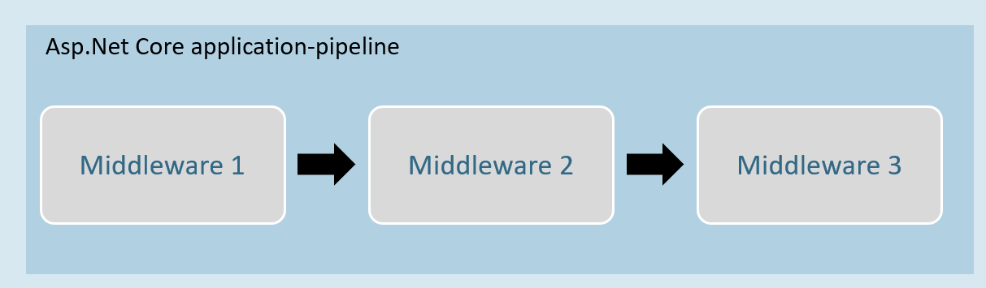

Middleware can be a request delegate (anonymous method or lambda expression) [or] a class.

**Middleware - Run**

**app.Run( )**

app.Run(async (HttpContext context) =>

{

//code

});

The extension method called “Run” is used to execute a terminating / short-circuiting middleware that doesn’t forward the request to the next middleware.

**Middleware Chain**

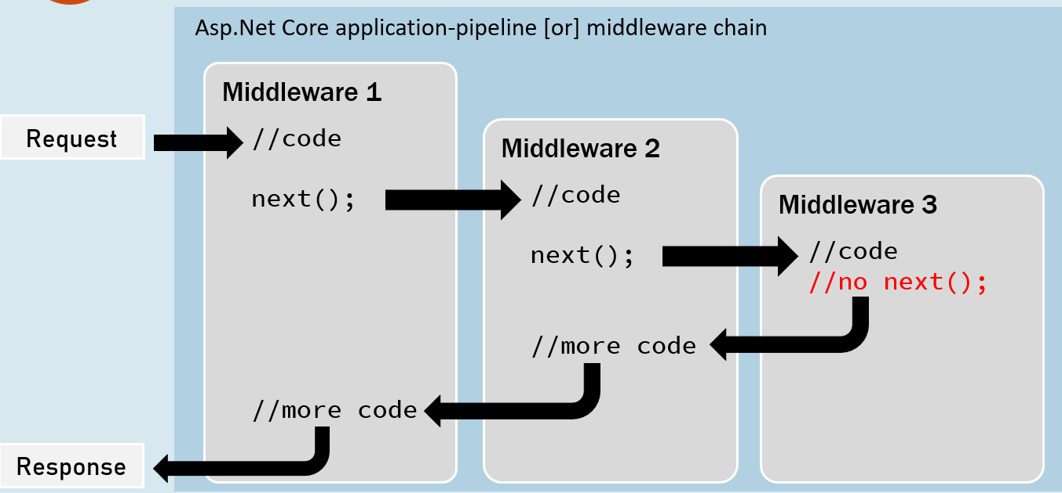

**app.Use( )**

app.Use(async (HttpContext context, RequestDelegate next) =>

{

//before logic

await next(context);

//after logic

});

The extension method called “Use” is used to execute a non-terminating / short-circuiting middleware that may / may not forward the request to the next middleware.

**Middleware Class**

Middleware class is used to separate the middleware logic from a lambda expression to a separate / reusable class.

class MiddlewareClassName : IMiddleware

{

public async Task InvokeAsync(HttpContext context, RequestDelegate next)

{

//before logic

await next(context);

//after logic

}

}

app.UseMiddleware<MiddlewareClassName>();

**Middleware Extensions**

class MiddlewareClassName : IMiddleware

{

public async Task InvokeAsync(HttpContext context,RequestDelegate next)

{

//before logic

await next(context);

//after logic

}

});

Middleware extension method is used to invoke the middleware with a single method call.

static class ClassName

{

public static IApplicationBuilder ExtensionMethodName(this IApplicationBuilder app)

{

return app.UseMiddleware<MiddlewareClassName>();

}

}

app.ExtensionMethodName();

**Conventional Middleware**

class MiddlewareClassName

{

private readonly RequestDelegate _next;

public MiddlewareClassName(RequestDelegate next)

{

_next = next;

}

public async Task InvokeAsync(HttpContext context)

{

//before logic

await _next(context);

//after logic

}

});

static class ClassName

{

public static IApplicationBuilder ExtensionMethodName(this IApplicationBuilder app)

{

return app.UseMiddleware<MiddlewareClassName>();

}

}

app.ExtensionMethodName();

**The Right Order of Middleware**

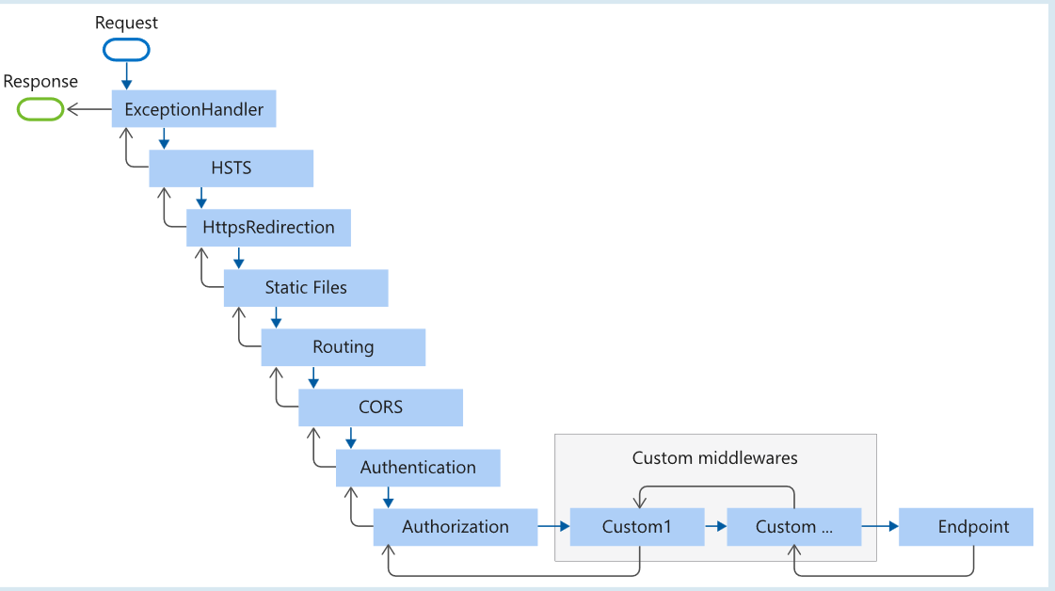

app.UseExceptionHandler("/Error");

app.UseHsts();

app.UseHttpsRedirection();

app.UseStaticFiles();

app.UseRouting();

app.UseCors();

app.UseAuthentication();

app.UseAuthorization();

app.UseSession();

app.MapControllers();

//add your custom middlewares

app.Run();

**Middleware - UseWhen**

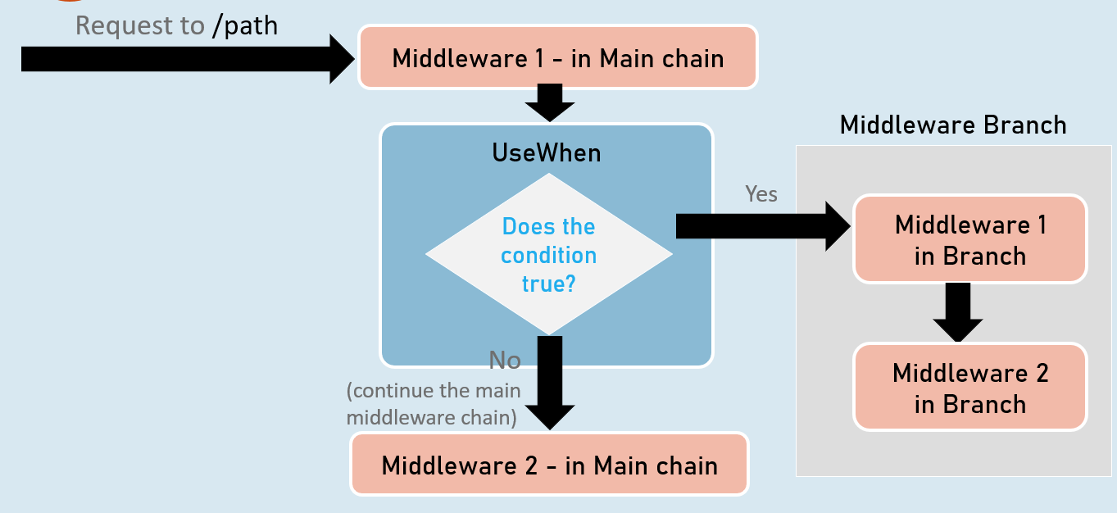

**app.UseWhen( )**

app.UseWhen(

context => { return boolean; },

app =>

{

//add your middlewares

}

);

The extension method called “UseWhen” is used to execute a branch of middleware only when the specified condition is true.